Set for code:

1. chrome://settings/help

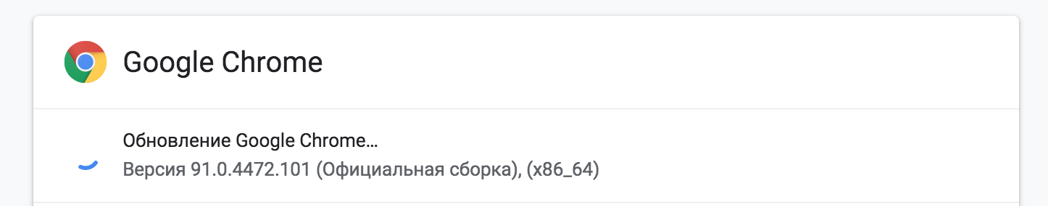

check version browser

2. Download google driver ( your version OS and google chrome)

<https://chromedriver.storage.googleapis.com/index.html>

3. Put google driver in folder ‘driver’ or replace file.

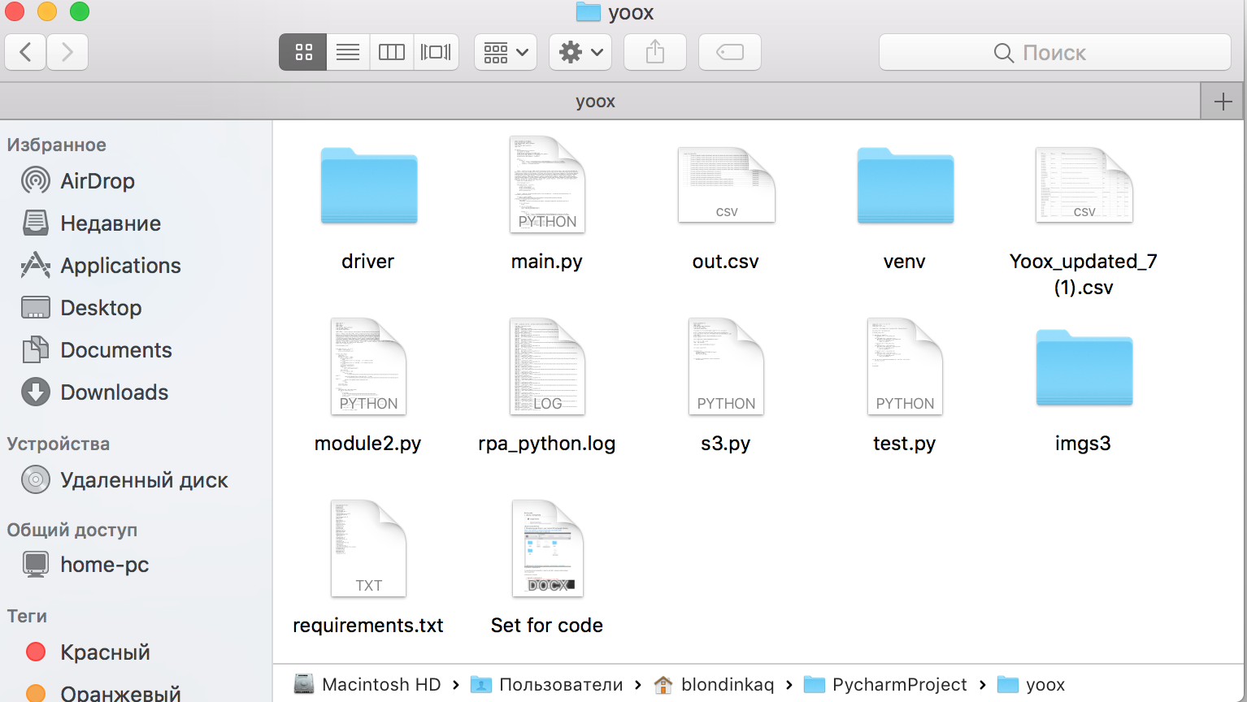

4. pip install –r requirements.txt

5. run py file and wait creating file csv name for each link ( command : python module2.py)

write any questions

ADDITIONAL FOR SET

This instruction for set s3 bucket:

https://towardsdatascience.com/how-to-upload-and-download-files-from-aws-s3-using-python-2022-4c9b787b15f2